
AD30NA4L（R100）

Feature
- Onboard Intel Alder Lake-N serial processor
- 1*DDR5 SO-DIMM，Max 16GB
- 4*2.5G network ports,choose POE
- TPM2.0，1*M.2 2280 SSD，MiniPCIe(WIFI/BT/4G/mSATA)
- HDMI2.0+DP,1*Type-C（USB+DP）
- DC 12-19V；Size：120x120mm

Specification
Processor | Onboard Intel Alder Lake-N serial processor,TDP 15W
Processor | EFI BIOS
Ram | 1*DDR5 SO-DIMM，Max 16GB
Rom | 1*M.2 M-Key 2280(NVMe PCIe 4.0 x2/SATA3.0 protocol)
Rom | 1*SATA3.0 slot，2Pin 5V power
Display port | 1*HDMI2.0,support 4096x2160@60Hz
Display port | 1*DP,support 7680x4320@60Hz
Display port | Type-C,support DP 7680x4320@60Hz and USB3.2 Gen2
I/O interface | Power button,reset button,2*USB3.0,2*USB2.0,TF card slot
I/O interface | DC JACK,HDMI+DP,Type-C
I/O interface | 4*2.5G LAN（3*Intel 226-V,1*RTL8156B，choose POE or not）,RJ45 console
Extended Interface/Function | External TPM2.0 is optional, but not by default. The default is CPU built-in TPM2.0
Extended Interface/Function | 1*MiniPCIe（PCIe+USB2.0+SATA3.0 protocol，WIFI/BT/mSATA module）,Micro SIM slot
Extended Interface/Function | 5*RS232 header，pitch 2.0mm；4*GPIO
Extended Interface/Function | 1*4Pin PWM CPU FAN
Power | DC 12-19V，over 36W
working environment | Working temperature: -20℃ ~ +60℃; Working humidity: 5% ~ 90%
working environment | Storage temperature: -40℃ ~ +85℃; storage humidity: 5% ~ 90%
operating system support | Windows10，Windows11，Linux
Size | 120x120 mm
net weight | About 120g without radiator, about 220g with radiator
AD30NA4L（R100）

Size Unit：mm
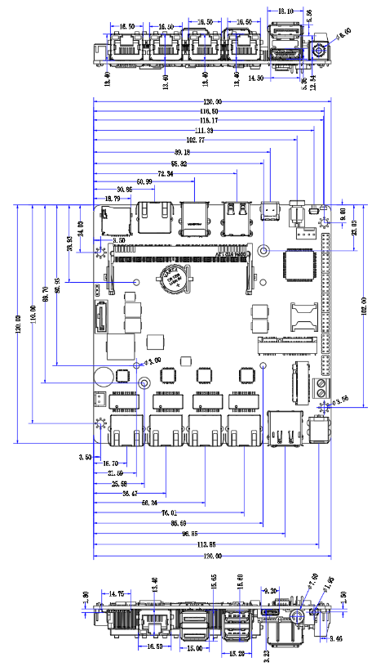

Order Information
Model | Optional | Optional Description
AD30NA4L | Onboard Intel Alder Lake-N serial processor | N95/N100/N300
AD30NA4L | POE | POE optional
AD30NA4L | TPM2.0 | External TPM2.0 optional

