
GN41NA（R120）

Feature
◆ Onboard Intel Gemini Lake/Gemini Lake-R processor
◆ support TPM2.0(optional)
◆ 2*I225 2.5G Lan card
◆ 1*VGA，1*HDMI 2.0
◆ 6*COM port； Onboard eMMC Storage Chip optional
◆ DC 12-19V

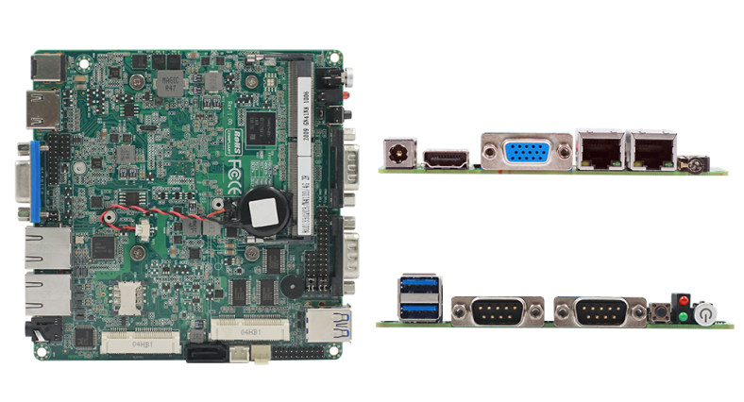

Specification
CPU | Integrated Intel Gemini Lake/Gemini Lake-R series CPU
CPU | EFI BIOS
Memory | 1*DDR4 SO-DIMM，max support 8GB
Display | 1*VGA，Support Resolution 1920x1200
Display | 1*HDMI2.0，Support Resolution 4096x2304@60HZ，Support 4K display
Display | HDMI+VGA Synchronous or asynchronous display
Storage | 1*SATA3
Storage | 1*mSATA
Storage | Onboard eMMC,32GB/64GB/128GB optional
Lan port | 2*Intel i225V 2.5G lan card
I/O port | 1*VGA，1*HDMI2.0
I/O port | 2*RJ45
I/O port | 2*USB3.0
I/O port | 2*DB9 RS232
I/O port | 1*DC JACK
expansion interface/function | 0-255 seconds, watchdog routine provided
expansion interface/function | Aluminum fanless radiator (mainboard reserved fan interface can support automatic and manual fan speed adjustment)
expansion interface/function | 4*USB2.0 pin header，2x5Pin，space 2.0mm
expansion interface/function | 6*COM port（4*RS232，2*RS232/RS485 optional），RS485 Supports automatic flow direction control
expansion interface/function | 8 bit GPIO，，2x5Pin，Space 2.0mm
expansion interface/function | 1个MiniPCIe socket，Support PCIe and USB2.0 device
Power supply | DC12-19V
Environment | Working temperature：-20℃ ~ +60℃；Working humidity:0% ~ 90% (non-condensing)
Environment | Storage temperature：-40℃ ~ +85℃；Storage humidity:0% ~ 90% (non-condensing)
OS | Windows10，Linux
Dimension | 120x120mm
Weight | With heatsink 260g，without heatsink 130g
GN41NA（R120）

Size Unit：mm

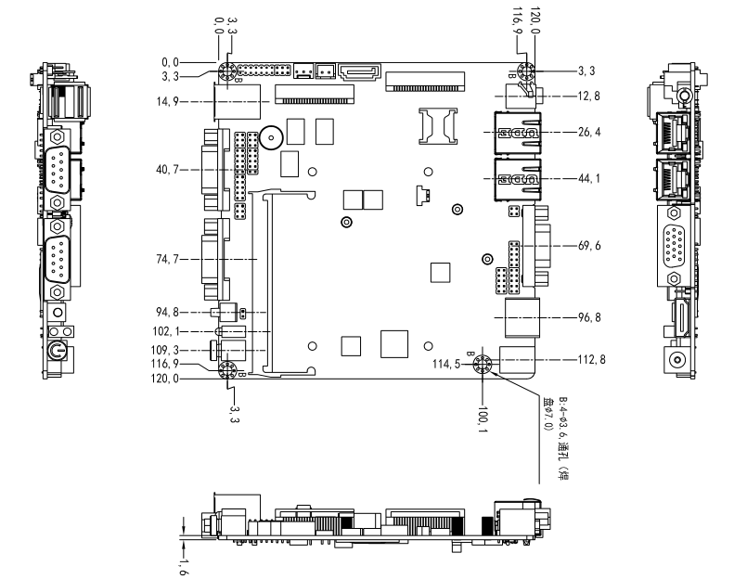

Ordering Information
Module | Optional | Optional description
GN41NA | Integrated Intel Gemini Lake/Gemini Lake-Rseries CPU | J4125/J5005/N4100/N5000
GN41NA | TPM2.0 | optional
GN41NA | COM port optional | 2com/6com
GN41NA | Onboard storage eMMC | 32GB/64GB/128GB optional

