
KU250Z3AW（R120）

Feature:
◆ Onboard Intel 6/ 7th Kaby lake-U series processor
◆ Onboard DDR4 Ram and one Ram socket
◆ VGA/HDMI/LVDS/EDP display
◆ Single and dual network optional, support AMT (requires CPU with Vpro platform function and Intel I219-LM network card)
◆ DC9-36V

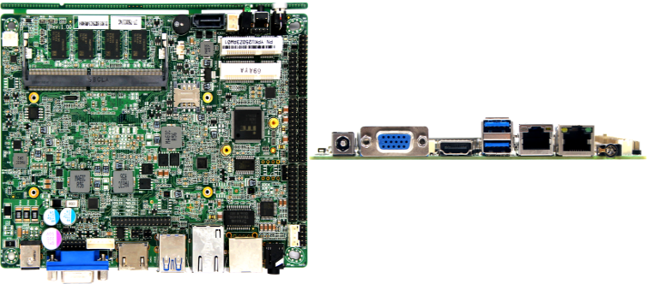

Specification
CPU | Onboard Intel Core 7th Kaby lake-U series SOC
CPU | EFI BIOS
Memory | Onboard 4GB/8GB DDR4 2133MHz；can add a Ram socket,max support 16GB
Display | Dual channel 24bit LVDS，1920x1200；EDP，4096x2304@60Hz（choose one of two）
Display | VGA，2048x1536
Display | HDMI1.4，4096x2304@24Hz，4K display
Display | Dual display, triple display, synchronous or asynchronous display
Storage | 1*SATA3
Storage | Onboard eMMC，32GB/64GB/128GB optional
Storage | 1*MiniPCIe mSATA，Support SANDISK protocol
I/O ports | 1*VGA，1*HDMI
I/O ports | 1*RJ45，2*USB3.0
I/O ports | 1*MIC-IN/LINE-OUT Audio
I/O ports | 1*DC Jack
Expansion | 1*Intel i225-V Lan card（When the I/O interface is 2 USB, the network card is 1 Intel i225-V network card and 1 Intel I219-LM Gigabit network card）
Expansion | 0-255 seconds watchdog, provide watchdog routine
Expansion | Aluminum fan radiator (supports automatic and manual fan speed adjustment)
Expansion | 2*USB3.0，6*USB2.0，4 of which are USB2.0 pin headers
Expansion | 5*RS-232，1*RS422/485 optional，RS485 Supports automatic flow direction control
Expansion | 1*PS/2 pin connector
Expansion | Support touch screen 4wire 5wire 8wire（optional）
Expansion | 8 bit GPIO
Expansion | 2*MiniPCIe slots, support PCIe and USB devices (MiniPCIe2 only supports PCIe protocol devices when touch screen is available)
Power supply | DC9-36V
Environment | Working temperature：-20℃ ~ +60℃；Working humidity:0% ~ 90% (non-condensing)
Environment | Storage temperature：-40℃ ~ +85℃；Storage humidity:0% ~ 90% (non-condensing)
OS | Windows10，Linux
Dimension | 155x117mm
Weight | With heatsink 280g，without heatsink 160g
KU250Z3AW（R120）

Size Unit：mm

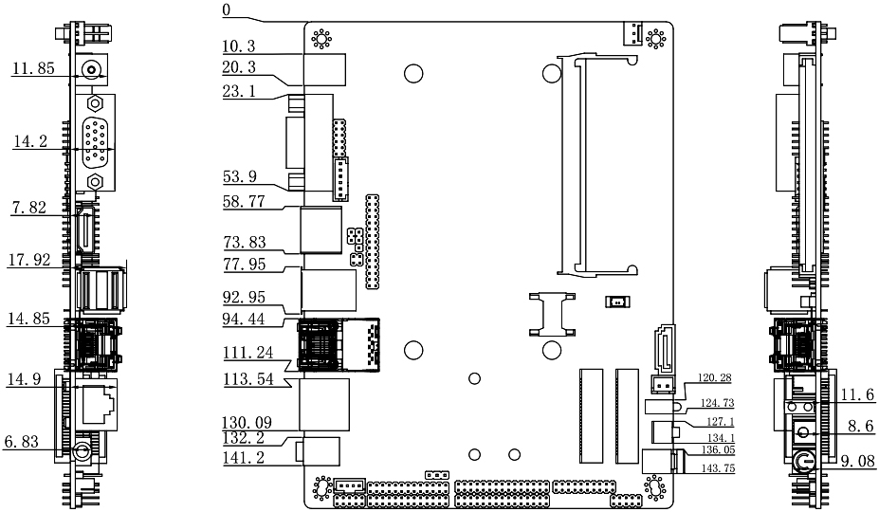

Ordering information
Module | Optional | Optional description
Onbaord Intel Core 6/7th Kaby lake-U series SOC | CPU | Celeron 3865/  I3-6100U/I3-7100U  I5-6200U/I5-7200U  I7-6500U/I7-7500U
Onbaord Intel Core 6/7th Kaby lake-U series SOC | Onboard Ram | 4GB/8GB optional
Onbaord Intel Core 6/7th Kaby lake-U series SOC | Onboard Storage | 32GB/64GB/128GB optional
Onbaord Intel Core 6/7th Kaby lake-U series SOC | Lan card | 1lan/2lan

